z
Report 47939 '"Returning the Favor" On Mother's Day'
Empowering the women of the urban slum

SI Madurai
[Type the company name]
[Pick the date]
To re-establish the lost glory and pride of mother, SI Madurai celebrated Mother's Day by initiating the project: "RETURNING THE FAVOR" on 15th May at Karambale Slum’s community hall, k.k.Nagar, Madurai.
We embarked this journey to empower the women of the urban slum as many women and girls face gender discrimination which systematically undermines their access to health care, for reasons that include fewer financial resources and constraints on mobility. This is compounded by additional burdens imposed by gender disparities which limit their ability to stay healthy. These include long hours spent on domestic work, unsafe work environments and gender-based violence, with mechanisms for prevention and protection are often inadequate.
SDG#3 (GOOD HEALTH AND WELL-BEING) and SDG# 5 (GENDER EQUALITY) was taken in consideration.
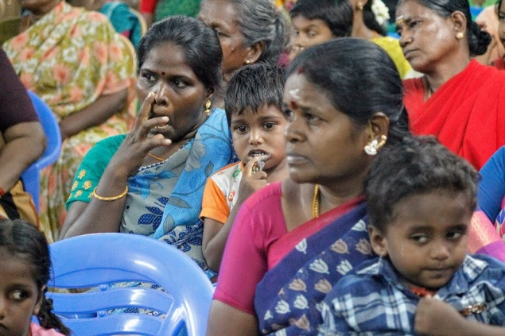We started by generating awareness amongst women and girls about menstrual health and hygiene via sensitization programs and parenting session. Women living in this slum endure many hardships when it comes to meeting their basic needs.
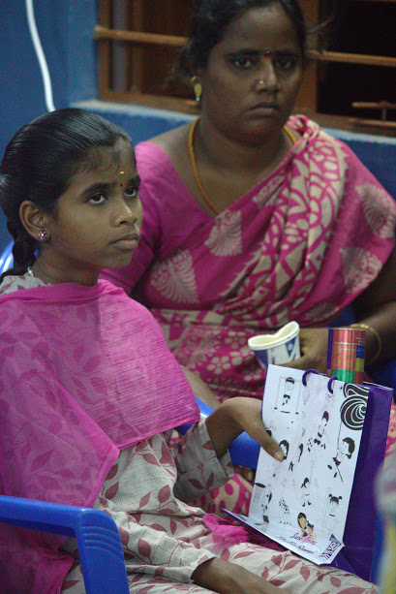They are encapsulated within their traditional and conservative role. These sessions on empowering and educating will motivate them to face intense competition in the labor market.
We strive to end practices that put women and girls in danger, such as child marriage, and support efforts to end discriminatory laws and practices impeding women’s access to sexual and reproductive health-care services.
The project Involved participatory planning and design tool by professional Doctors who shared their expertise with women of this urban slum to answer their queries on health issues and motivate them to be empowered. This program involved Gynaecologist Dr. Sudha Dheep (SI Madurai member), Paediatrician Dr. Prasanna, and Dietician Dr. Murugeswari. Bringing these women, girls and children together was a challenge which was well done by the volunteers of the slum.

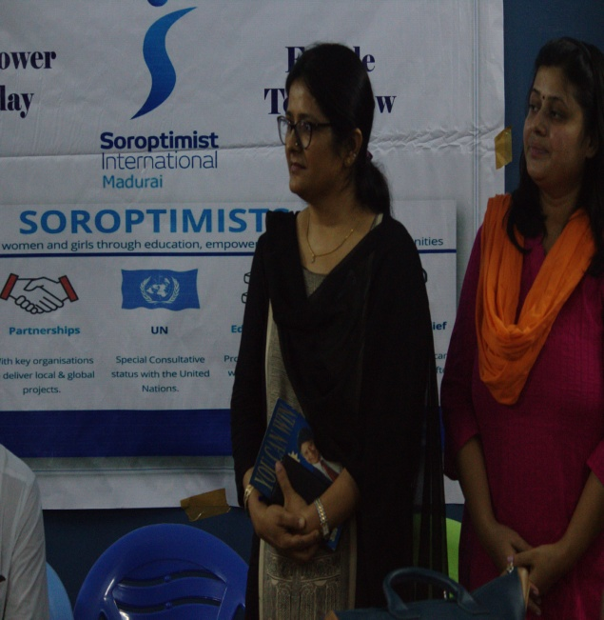
Outcome of “Returning the Favor" : The project equips women living here in urban slam, to make critical decisions that radically improve their health and that of their families. Women and girls, everywhere, must have equal rights and opportunity, and be able to live free of violence and discrimination. Eliminating gender-based violence is a priority, given that this is one of the most pervasive human rights violations in the world today.
